Charles Marcus

Orion Research Project

9/9/15

Lunar Phase Pedagogy

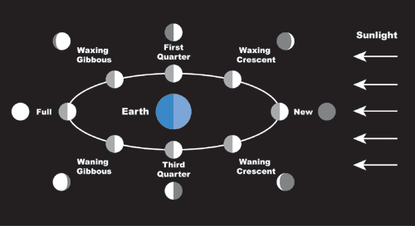 Lunar phases are simply described as the shapes of the moon visible on earth due to illumination by the sun’s light. The moon is tidally locked with the Earth, meaning that the same lunar surface faces the Earth. These phases change due to the position of the moon in its own orbit around the Earth. Due to this correlation with orbit position, lunar phases change cyclically, starting with 0% of the moon visible and then can reach 100% visibility. We describe different lunar phases based on how much of the lunar surface is illuminated.

Referring the figure above, we see the different lunar phases illustrated, with both the light and dark hemispheres of the moon. There are four principal lunar phases: first quarter, full, third quarter, and new. These instances are the differences between the lunar celestial longitude and solar longitude at 0◦, 90◦, 180◦, 270◦. As the lunar phases approach full, the moon is said to be “waxing” and “waning” when the phases approaches new. Each of the four principle phases last about 7.38 days, transitioning through gibbous and crescent states. These lunar phases are also visible at different times during the solar day due to the moon’s current position in the lunar orbit.